April 2024

KMC Notes

Save the Dates …
Worship Services
Sunday, April 7 (Second Sunday of Easter)
Walk Up Offering
Sunday, April 14 (Third Sunday of Easter)
Preschool Sunday
Sunday, April 21 (Fourth Sunday of Easter)
Sunday, April 28 (Fifth Sunday of Easter)

LET’S KEEP A GREAT YEAR GOING!

As I look back on this past month, in many ways March was a great month at King Moravian. Some of the things that made it great were:

• Worship services with many people coming and watching!
• A family bringing their children before the Lord for baptism and the husband/father joining our
church family!
• An incredible turnout for our Preschool’s Bingo fundraiser and a lot of money raised for our
Preschool!
• A group of young people taking part in our church’s Confirmation Class who were excited about
being baptized and confirmed and joining our church!
• Another successful Pine Needle sale by our men with around 1,400 bales of pine needles sold!
• Some incredible music by Drake, Jennifer, our Choir, and other musicians throughout the month!
• Our Capital Campaign with its total in pledges and money given is now over $400,000!
• A meaningful Holy Week with those coming to and watching our Holy Week Services and many
taking part in our Cross Walk!
• A glorious Easter with many at our Sunrise Service and a large crowd at our Easter Worship
Service!

Throughout this past month and really throughout this year, we have momentum at King Moravian. Momentum is powerful! We see it a lot in sports. If you are paying attention to one of our North Carolina sports teams, you have seen the power of momentum in the North Carolina State University men’s basketball team. Before the Atlantic Coast Conference tournament, they lost four games in a row. During the ACC tournament, they won five games in five days and their momentum of playing together and being committed to what they were doing led them to the ACC championship. Their momentum has since carried them through the first round of the national tournament, the second round, the Sweet Sixteen, the Elite Eight, and now they are in the Final Four! It is tough for a Carolina guy to say this, but “Way to go, Wolfpack!”

I feel we have a lot of momentum. We have many people who love the Lord and love this church family. We have many who are committed to being here, committed to serving the Lord through the ministry of this church, and committed to giving to what we are doing for the Lord. We have a lot more great things ahead of us – services, programs, studies, fellowship opportunities, a 100th anniversary celebration, and capital campaign goal to meet. As we move ahead from March and move on from Easter, let us keep the momentum going! If you have not been coming or serving or giving, get on board and be part of something great! May we all do our part to continue to make it a great year at King Moravian!

In Christ’s love and service,
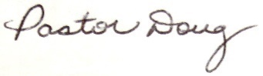
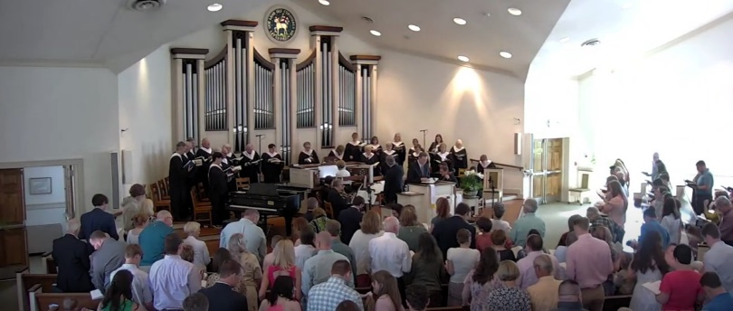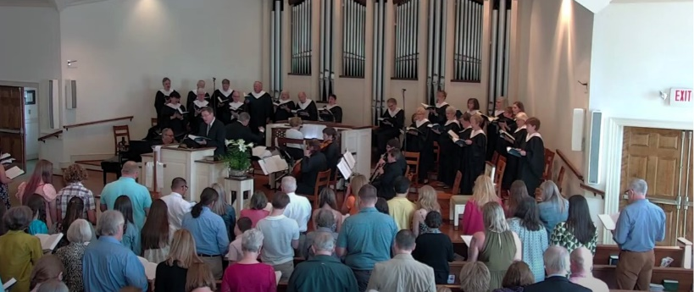

Easter Sunday Worship Service
OUR CAPITAL CAMPAIGN CONTINUES!
IN ALL THINGS LOVE – RESTORE, RENEW, REJOICE!
WE’RE OVER THREE FORTHS THERE!!!
LET’S TAKE CARE OF OUR CHURCH HOME!!!
2022-2024 Capital Campaign Update

Goal: $500,000

Number of those who pledged: 82

Total Pledge Amount: $379,517.08

Pledges and Money Received: $406,088.25

(This amount includes pledges, one-time gifts, fundraisers,
memorials, and honorariums.)

We're Restoring! We're Renewing! We're Rejoicing!
We've completed Phase One of our Capital Campaign projects with the installation of heating and air and it in the old balcony which includes a new storage space for music, and an office for our Director of Music. It also included updated heat and air conditioning to the third floor of the Christian Education part of our building. The other phases of our Capital Campaign include updated heating and air conditioning for our Sanctuary and Fellowship Hall, work on our Picnic Shelter, and having funds available when we need a new roof. In addition, ten percent of our campaign will go to King Outreach Ministry and our church’s Mission Blitz.
Thank you to everyone who is making all of this possible! We continue to ask those who have not made a pledge or given anything to the campaign to prayerfully consider what you can do to help. We also encourage everyone to consider an even greater pledge or a greater gift.
SERVICES AND EVENTS IN APRIL
PRESCHOOL SUNDAY
SUNDAY, APRIL 14
On Sunday, April 14, we will have our Preschool Sunday. Our service will include special music and special sharing from those associated with our Preschool program. At King Moravian we are blessed with a wonderful Preschool, and we hope you will be here for this special service.

WEDNESDAY NIGHT DINNER – WEDNESDAY, APRIL 3
On Wednesday, April 3, we will have the first of two Wednesday Night Dinners in April and May. For the April Wednesday Night Dinner, we will have a cookout with hot dogs and all the fixings provided by our Joint Board. Besides eating, we will also join in singing some camp songs. Everyone is welcome to attend. The other Wednesday Night Dinner will be on Wednesday, May 1.

HOT DOG LUNCHEON AFTER CHURCH FOR THE YOUTH MISSION TRIP –
SUNDAY, APRIL 14
On Sunday, April 14, following our worship service our Senior Highs and Middle Highs invite everyone to a Hot Dog Luncheon. The meal is free and our youth will also receive donations for their upcoming summer mission trip to Nashville. Everyone is welcome to attend.
MEN’S BREAKFAST – SUNDAY, APRIL 21
Our next Men’s Breakfast is Sunday, April 21, at 8:30 a.m. in the Fellowship Hall. All men of our church and guests are invited. There will be a signup sheet at the church which we encourage those coming to sign so we know how many to plan for. If you would like to help with the breakfast, please contact Mike Handy.

COMMUNITY YARD SALE – FRIDAY, APRIL 26 AND SATURDAY, APRIL 27
We will have our Community Yard Sale Friday, April 26, and Saturday, April 27. We are not receiving clothes this year, but we will take shoes and accessories. We will soon have more information about bringing items and days and times when we need people to help.

COMING UP IN MAY

MOTHER’S DAY AFTERNOON TEA – SATURDAY, MAY 18
The Circle of Hope invites you for a special afternoon of high tea and treats on Saturday, May 18th from 11 a.m. to 1 p.m. Extend the hand to your daughter, mother, or a sister in Christ for a lovely afternoon of fellowship. Tickets are $10.00.

LAUREL RIDGE OPPORTUNITIES
Our Joint Board would like to offer our church family the opportunity to spend some time at Laurel Ridge, our Moravian Church Camp in the Blue Ridge Mountains. At this time, we are looking into renting the Picnic Shelter at the camp on Sunday, May 26. People can come up and spend the day, and we will probably have some type of meal together (potluck, cookout, etc.). We are also looking into renting part of Higgins Lodge for the weekend of September 6 through September 8. We plan to have a survey soon to see who is interested in either or both opportunities. If you are interested or have any questions, please contact Holly Mathis or call the church office.

WELCOME TO OUR NEWEST MEMBERS

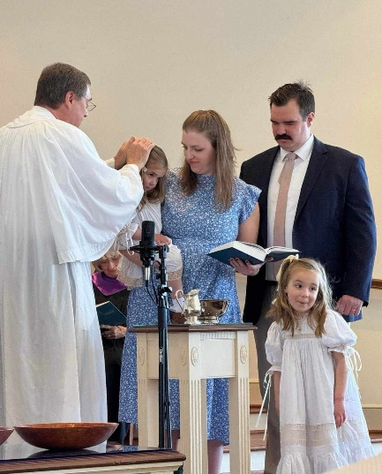

On Sunday, March 10, Cooper and Rachel Smith brought their daughters, Mary and Frances, before the Lord for baptism. That Sunday we also welcomed Cooper as a member of our church family.
Cooper transfers his membership from the Trinity United Methodist Church in King. He works for Corning Optical Cable in Winston-Salem. Some of the ways Cooper would like to serve in our church family is help with church maintenance, serve as an usher, a greeter, and a lay reader, and help with our Mission Blitz. Cooper’s shepherd is Darrell Goins.

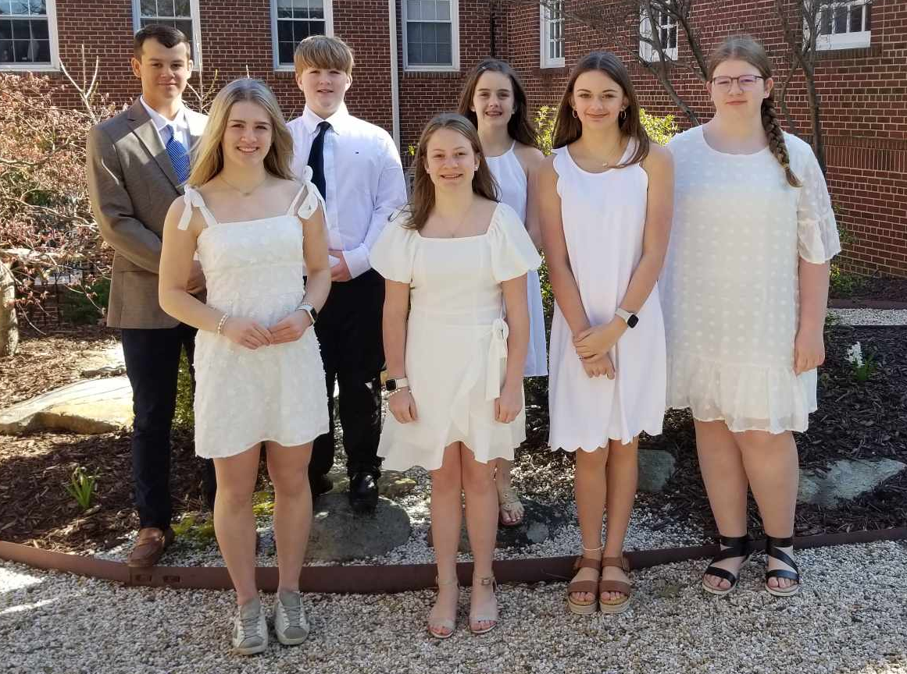

On Sunday, March 24, Palm Sunday, we welcomed the members of our Confirmation Class who came before the Lord for baptism and confirmation. Those who joined our class were:
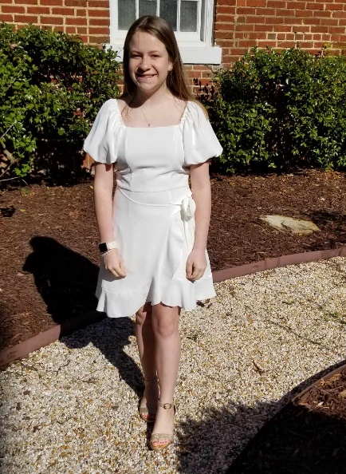
Hannah Duncan
Hannah joined our church by confirmation. She is the daughter of Jay and
Emily Duncan. Hannah is in the 7th grade at Chestnut Grove Middle School.
Some of the ways Hannah would like to serve in our church family are help with
indoor projects, help with Vacation Bible School, and play handbells. Hannah’s
Confirmation Class mentor is Desty McEwan.

Katharine Grabs
Katharine joined our church by confirmation. She is the daughter of Kip Grabs
and Paula Hall. Hannah is in the 6th grade at Chestnut Grove Middle School.
Some of the ways Katharine would like to serve in our church family are help with
indoor and outdoor projects, help with Mission Blitz, and help with Vacation Bible
School. Katharine’s Confirmation Class mentor is Meredith Smith.

Emily Hepler
Emily joined our church by confirmation. She is the daughter of Ben and Katie
Hepler. Emily is in the 7th grade at Chestnut Grove Middle School. Some of the
ways Emily would like to serve in our church family are be a lay reader, help in our
Nursery and Children’s Church, and learn to play handbells. Emily’s Confirmation
Class mentor is Terri Lyda.

Kate Southern
Kate joined our church by confirmation. She is the daughter of Bill and Beth
Southern. Kate is in the 8th grade at Chestnut Grove Middle School. Some of the
ways Kate would like to serve in our church family are help with indoor projects,
serve as a diener, and help in our Nursery and Children’s Church. Kate’s
Confirmation Class mentor is Renee Bowman.
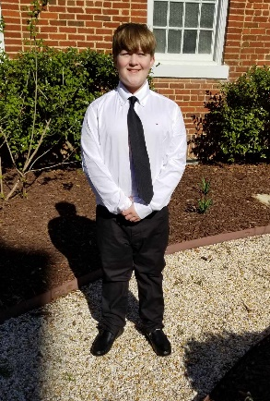
Flynn Southern
Flynn joined our church by confirmation. He is the son of Bill and Beth
Southern. Flynn is in the 6th grade at Chestnut Grove Middle School. Some of the
ways Flynn would like to serve in our church family are help with outdoor projects,
serve as a greeter, and help in our Bible Time. Flynn’s Confirmation Class mentor
is Homer Dearmin.
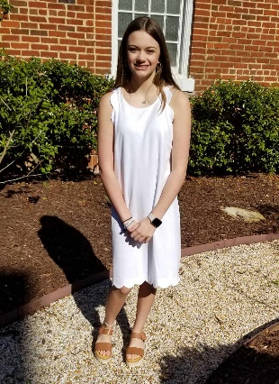

Mallorie Wall
Mallorie joined our church by confirmation. She is the daughter of Kent and
Jessica Wall. Mallorie is in the 6th grade at Chestnut Grove Middle School. Some
of the ways Mallorie would like to serve in our church family are help with indoor
projects, serve as a greeter, and help with our Nursery. Mallorie’s Confirmation
Class mentor is Barbara Sudol.
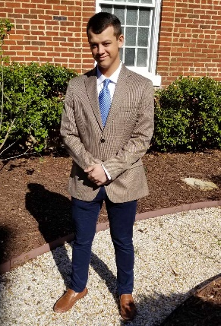

Harrison Wright
Harrison joined our church by adult baptism. He is the son of Ricky and Amanda
Wright. Harrison is in the 10th grade at Reagan Senior High School. Some of the
ways Harrison would like to serve in our church family are help with outdoor projects,
serve as an usher, and serve as a lay reader. Harrison’s Confirmation Class mentor
is Paula Hall.

CHURCH FAMILY NEWS

Our church family extends its Christian love and sympathy to Myra Wright and her family upon the passing of her stepfather, Dexter Newsome, on March 24.

In the hospital since our last newsletter have been Gary Monteith, Ken Sevier, and Jozi Stevens.

SPECIAL WORDS OF THANKS

We thank those from our church family who helped with the Stokes County Clean-Up on March 9.

We thank everyone who helped with our Men’s Fellowship Pine Needle Sale on March 23. We also thank everyone who purchased the bales of pine needles. Special thanks to Robert Simpson for all his work in getting this project together. Proceeds from this event will go to help with church projects.

We thank everyone who came to our Easter Egg Hunt on March 10. Special thanks to Rachael Butts and all who helped her make this a great event for our children and their families.

We thank those who provided special music for our Holy Week Services who included Annette Covington, Jennifer Dunn, Thao Nguyen, Karl Ronnevik, and our Choir. We also thank those who assisted in the Holy Week Readings who were Homer Dearmin, Doug Gordon, Mark Johnson, Terri Lyda, Leah Simpson, and Tate Shore. Special thanks to Jimmy and Juli Owen who took care of livestreaming all of the Holy Week Services.

We thank the many people who made our Easter celebration a special time for our church family. We thank Corky Newsome and Ken Sevier for all the work they did for our God’s Acre. We thank everyone who brought flowers for the graves in memory of loved ones. Special thanks to Shiela Patterson for her work in making sure all the graves had flowers and to those who contributed flowers. Thank you to Ken Lyda and all who helped him in getting our speaker system set up for the Sunrise Service and serving as ushers. We thank Drake Flynt for taking care of the music for our Sunrise Service and we thank our musicians for the service who were Anita Cirba, Guy Kelvin, Joe Mount and Ken Wilmont. We thank Mike Handy and those who helped with the Easter Breakfast. We thank those who provided the wonderful music for our Easter Worship Service who included Drake Flynt, Jennifer Dunn, our Choir, and our musicians for the service who were Ashley Barrett, Annette Covington, Matthew Covington, Matt Kiefer, Karl Ronnevik, and John Pruett. We thank everyone who came to our services. It was wonderful seeing a great group at God’s Acre for the Sunrise Service and it was wonderful to the many people who shared in our Easter Worship Service.

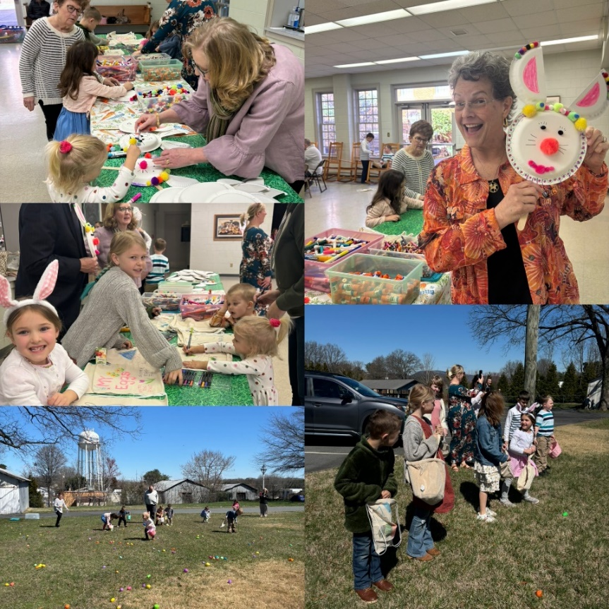
Easter Egg Hunt and crafts

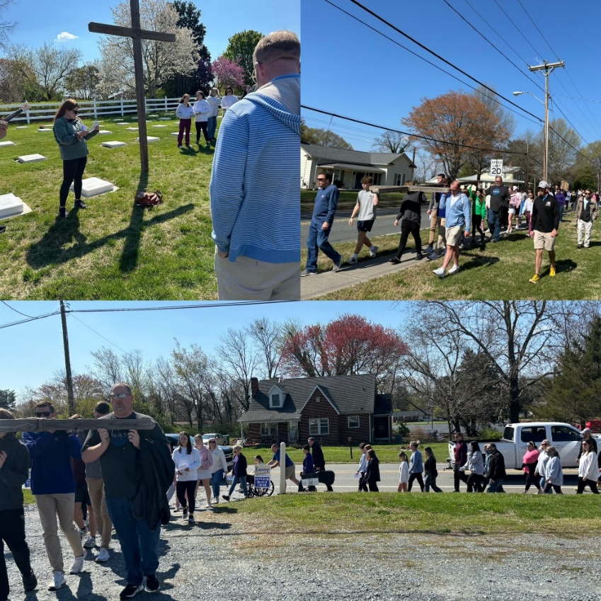
Crosswalk
YOUTH FELLOWSHIP

PROGRAMS AND EVENTS IN APRIL

SENIOR HIGHS AND MIDDLE HIGHS
April 10 – StoCo at 6:30
April 14 – hot dog dinner fundraiser (tentative)
April 24 – StoCo at 6:30

JUNIORS
April 7 – lunch and roller skating after church
April 21 – lunch and bible study on angels after church

BRANDON, BOOE, JONES FAMILY AND JOHNSON SCHOLARSHIPS APPLICATION
Our church offers four scholarships for members who need financial support for their education. Applications are available at the Church Office and on the church’s website starting March 1st and must be returned by May 1st.

2023 LAUREL RIDGE SUMMER CAMP SCHEDULE
Pre-Junior 1 (grades 1-2) June 16-18
Pre-Junior 2 (grades 1-2) July 28-30
Junior 1 (grades 3-5) June 18-24
Junior 2 (grades 3-5) July 30 - August 5
Middle High 1 (grades 6-8) June 25 - July 1
Middle High 2 (grades 6-8) July 9-15
Senior High (grades 9-12) July 16-22

2023 SPECIALTY CAMP SCHEDULE
Creative Arts Camp June 25 - July 1

2023 MISSION CAMP SCHEDULE
Mission Camp 1 June 11-17
Mission Camp 2 June 18-24
Mission Camp 3 July 23-29
Mission Camp 4 July 30 – August 5

For more information about any of these camps, please check the Laurel Ridge website which is www.laurelridge.org.

IMPORTANT CAMP SCHOLARSHIP INFORMATION
Our church provides a camp scholarship for our young people who attend church camp at Laurel Ridge. Our church will pay one half of the camp fees for one camp for any of our members and family members who are active in our congregation. When you register, please use the code “king2023” for the scholarship for the weeklong camps and the code “king2023pj” for the scholarship for Pre-Junior camps. If there is a financial need, please let us know because there may be other sources of funding for our church camps.

April Birthdays
3- Amy Reeves  3- Charles Reeves  5- Elizabeth Duncan  9- Jennifer Burge-Carter  11- John Matthews  12- Candice Covington  13- Ethan Moran  16- Eddie Harper  19- Derek Hughes  19- Rachael Butts  20- Billy Boaz  20- Tom Pace  21- Carolyn Newsome  22- Gaylon Moran  22- Noah Hall | 22- Hillary Douglas  23- TJ Magaraci  23- Avery Pace  24- Mike Handy  24- Tate Shore  25- Sarah Stevens  26- Kristin Smith  27- David Smith  27- Dwayne Pratt  28- Bob Sullivan  29- April Strader-Bullin  29- Susan Smith  29- Paula Jennings  29- Elizabeth Grabs  30- Grant Butts

Financials

Offerings received through March 30: $86,601
Budget expenses through March 30: $100,815
2022 monthly contribution for shared Moravian Church Ministries: $4,486.00 per month has been paid through March.

CHURCH GIVING
We appreciate all gifts that are given for the ministry of our church family. There are several ways which you can give your gifts which are the following:
● You can bring your contributions to our worship services.
● You can mail your contribution to the church at King Moravian Church, 228 W. Dalton Road,
King, NC 27021.
● You can bring your contribution to the church office and deposit it in the slot in the security box
affixed to the wall outside the office door.
● You can give online. For online giving, go to our church’s website (www.kingmoravianchurch.org)
and click on the “Online Giving” link which will take you to our King Moravian Church Donation
Form through the Moravian Ministries Foundation.
CHURCH SCHEDULE FOR APRIL

April 2 Book Club Meeting – 5:30 p.m.

April 3 Wednesday Night Dinner at the Picnic Shelter – 6:00 p.m.

April 4 Writing Class in the Church Office – 6:00 p.m.
Lenten Study in the Fellowship Hall – 6:30 p.m.

April 7 Walk Up Offering
Worship Service – 11:00 a.m.
Juniors – lunch and roller skating after church

April 8 Handbell Practice Resumes – 6:00 p.m.

April 9 Joint Board Meeting – 6:30 p.m.

April 10 Joint Boards meet with the PEC to begin call process – 6:30 p.m.
Senior Highs and Middle Highs meet at StoCo – 6:30 p.m.

April 13 KMP Art in the PARKing Lot – 11:00 a.m. – 2:00 p.m.

April 14 Preschool Sunday
Worship Service – 11:00 a.m.
Senior Highs and Middle Highs Hot Dog Luncheon fundraiser (tentative)

April 17 100th Anniversary Committee Meeting – 6:00 p.m.

April 21 Worship Service – 11:00 a.m.
Circle of Faith meeting in Ladies Parlor – 12:30 p.m.
Juniors – Lunch and Bible Study on Angels after church

April 22-26 KMP Spring Break
April 24 Senior Highs and Middle Highs meet at StoCo – 6:30 p.m.

April 26 KMC Yard Sale

April 27 KMC Yard Sale

April 28 Worship Service – 11:00 a.m.

PRESCHOOL NEWS
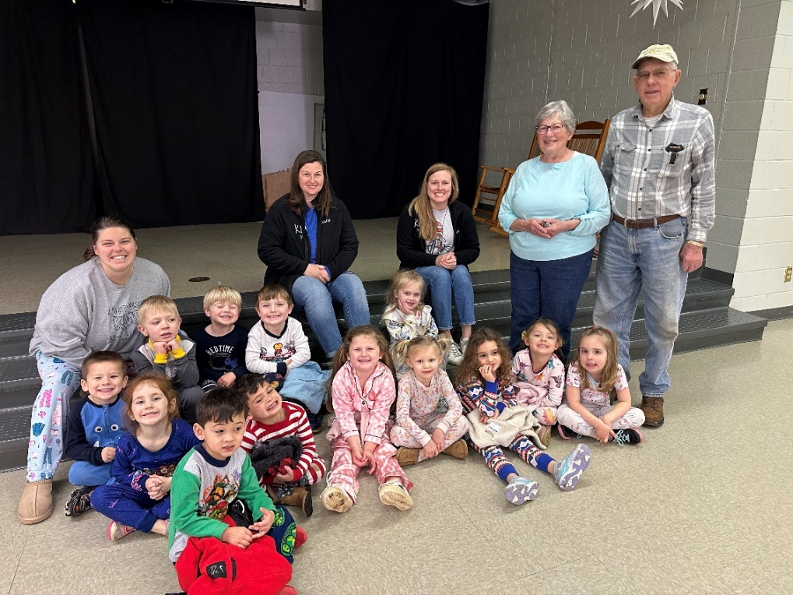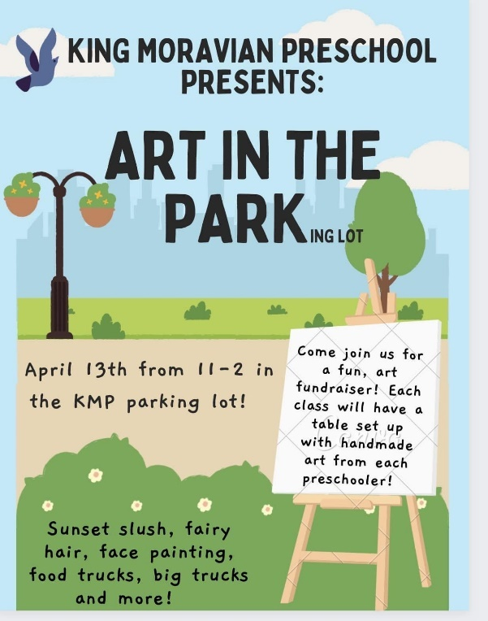
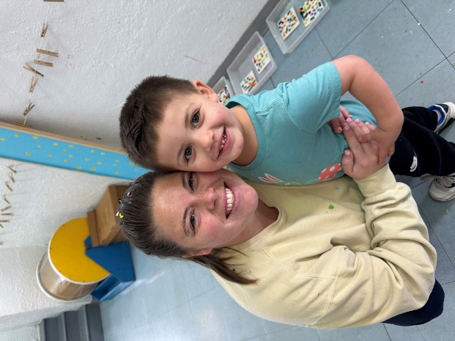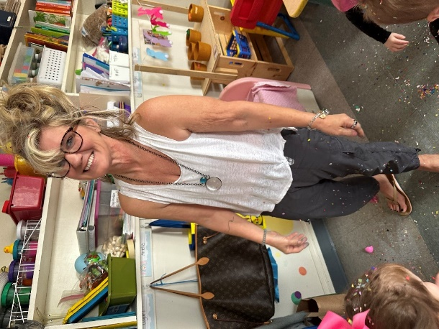
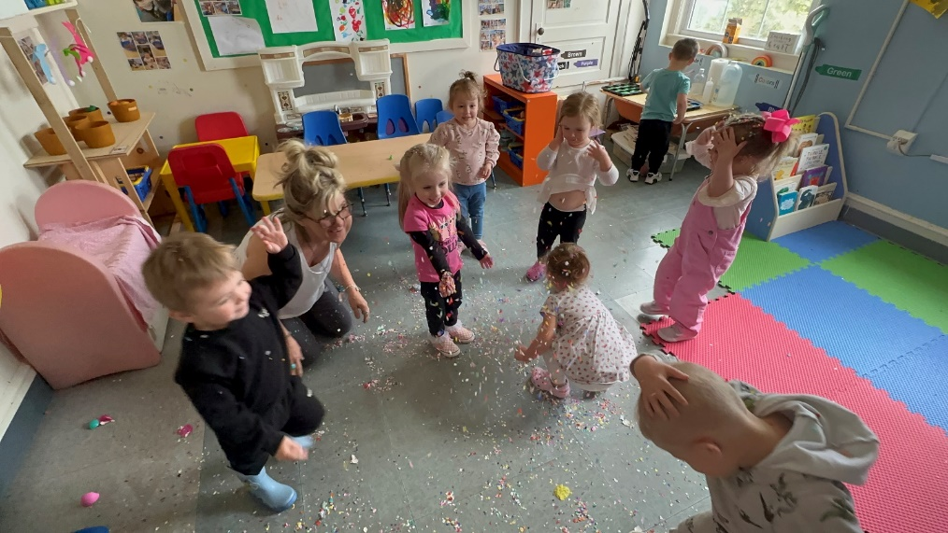
Pray Every Day April 2024
(A list of daily prayer concerns from our Board of World Mission)
- Shout for joy to the Lord, all the earth. Worship the Lord with gladness; come before him with joyful songs. Pray for the Teshes in Kenya and Ray of Hope.
- For the Lord is good and his love endures forever; his faithfulness continues through all generations. Pray for peace in Ukraine.
- I will sing of your love and justice; to you, O Lord, I will sing praise. Pray for the Raipur Foster Child Project.
- Hear my prayer, O Lord; let my cry for help come to you. Pray for Phil and Eunice Raiford in Mexico.
- Do not hide your face from me when I am in distress. Turn your ear to me; when I call, answer me quickly. Pray for Moravians in Honduras and Nicaragua.
- Praise the Lord, O my soul; all my inmost being, praise his holy name. Pray for the conflict in the Middle East.
- The nations will fear the name of the Lord, all the kings of the earth will revere your glory. Pray for PEC members, bishops, and other church leaders.
- The Lord works righteousness and justice for all the oppressed. Pray for Adopt-a-Village in Tanzania.
- The Lord is compassionate and gracious, slow to anger, abounding in love. Pray for Moravians in Cuba and the Armando Rusindo Foundation.
- For as high as the heavens are above the earth, so great is his love for those who fear him; as far as the east is from the west, so far has he removed our transgressions from us. Pray for the Sineaths in Campus Outreach.
- O Lord my God, you are very great; you are clothed with splendor and majesty. Pray for the Clinica Evangelica Morava in Ahuas.
- May my meditation be pleasing to him, as I rejoice in the Lord. Pray for the Unity Women’s Desk.
- Give thanks to the Lord, for he is good; his love endures forever. Pray for Moravians in Peru.
- Who can proclaim the mighty acts of the Lord or fully declare his praise? Pray for the Hoffmans in HIV/AIDS ministry.
- Let them give thanks to the Lord for his unfailing love and his wonderful deeds for men. Pray for seminarians and candidates for ordination.
- My heart is steadfast, O God; I will sing and make music with all my soul. Pray for City With Dwellings in Winston Salem.
- I will praise you, O lord, among the nations; I will sing of you among the peoples. Pray for Safiatu Braima and Sierra Leonne.
- For great is our love, higher than the heavens; your faithfulness reaches to the skies. Pray for Kevin and Charity in the Middle East.
- Be exalted, O God, above the heavens, and let your glory be over all the earth. Pray for short term mission teams.
- Save us and help us with your right hand, that those you love may be delivered. Pray for the Harrisons with Greek Intervarsity.
- With my mouth I will greatly extol the Lord; in the great throng I will praise him. For he stands at the right hand of the needy one, to save his life from those who condemn him. Pray for Anna Faircloth with YoungLife.
- Great are the works of the Lord; they are pondered by all who delight in them. Pray for Brian and Heather Marx with Mission Aviation Fellowship.
- He will have no fear of bad news; his heart is steadfast, trusting in the Lord. Pray for Alan and DeeDee Iobst in France.
- From the rising of the sun to the place where it sets, the name of the Lord is to be praised. Pray for Charlie and Vicki Brent in Texas.
- Not to us O Lord, not to us but to your name be the glory, because of your love and faithfulness. Pray for Annie B Missions and Star Mountain.
- I love the Lord, for he heard my voice; he heard my cry for mercy. Because he turned his ear to me, I will call on him as long as I live. Pray for Moravian churches in Czech Republic housing refugees.
- Praise the Lord, all you nations; extol him, all you peoples. Pray for the Board of World Missions.
- The Lord is my strength and my song; he has become my salvation. Pray for Michael and Brenda Brent in Croatia.
- I will not die but live, and will proclaim what the Lord has done. Pray for Estamos Unidos Moravian Ministry.
- Do good to your servant, and I will live; I will obey your word. Pray for Joey Yokeley with Fellowship of Christian Athletes.

KMC Notes
April 2024
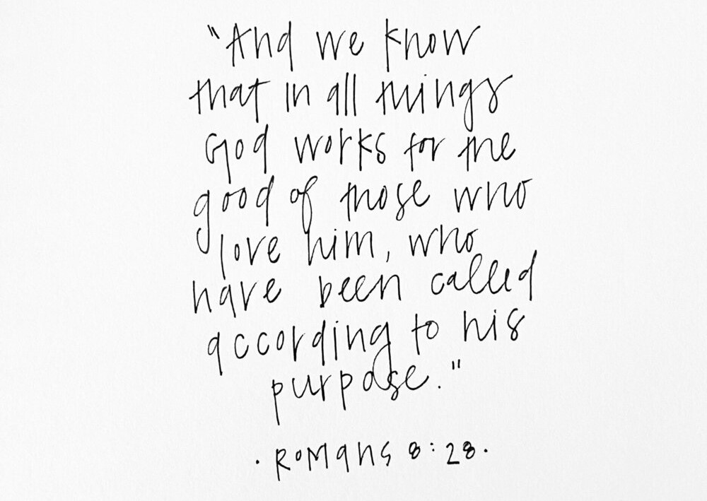

King Moravian Church
228 West Dalton Rd.
King, NC 27021

