Poinsettias Given In Memory

Carolyn Byerly My loving husband, Bill Byerly
Scott, Tracy, Cole and Mary Cardwell Walt Justis
Scott, Tracy, Cole, and Mary Cardwell John and Linda Williard
Ed and Ann Deal In Memory of loved ones
Jay and Sue Donathan C.J. and Bea Donathan
Jay and Sue Donathan Fred and Dora Watson
Hillary Douglas Garrell Douglas Sr.
Hilary Douglas G. W. Douglas
Hilary Douglas Carolyn Douglas
Lisa and Kirt Earley Bill Byerly
“Nick” Elliott, Joel and Becky Reba Elliott
Budge Gage, Juli and Jimmy Owen Vonnie Gage
Budge Gage, Juli and Jimmy Owen Riff and Mary Lib Gage
Budge Gage, Juli and Jimmy Owen Roger and Beatrice Slate
The Grabs Family Omnie Grabs Jr.
Bill and Margie Hall Our Family
Sally Hartgrove Dean Hartgrove
Sally Hartgrove Stanley Hartgrove
Fredrick Johnson and Gale Stone Johnson Dick and Myrtle Stone
Fredrick Johnson and Gale Stone Johnson Otis and Lillian Johnson
Fredrick Johnson and Gale Stone Johnson Hylton Wright
Fredrick Johnson and Gale Stone Johnson Jessie and Buster Stone
Fredrick Johnson and Gale Stone Johnson Dr. and Mrs. G. E. Stone
Fredrick Johnson and Gale Stone Johnson Mr. and Mrs. P. G. Wall
Mark and Heather Johnson Roger Cooke
Mark and Heather Johnson Buck and Bettye Johnson
Anita Jones Angus Hammond
Anita Jones Mary and Gib Hammond
Dottie Jones Dr. and Mrs. J. R. Jones
Dottie Jones Reid and Dorothy Jones
Doug and Debra Jones Gene and Louise Chapman
Doug and Debra Jones Bill and Carolyn Jones
Lori Justis Walter Justis
The Kiger Family Joel Kiger Sr.
The Kiger Family Scott Kiger
John and Robin Kincaid John E. Kincaid II and Delphine Kincaid
John and Robin Kincaid Richard and Ottie Sapp
Steve Kincaid Willie Mae Hastings
Don and Fran Lucas Roger Cooke
Don and Fran Lucas Our Parents: Havens & Woodrow Lucas and Agnes & Grady Stewart
Ken and Terri Lyda Linda Lyda
Ken and Terri Lyda Sybil Moore
Ken and Terri Lyda Abrian Lindsay
Fran Newsom Ted Carmichael
Fran Newsom Rev. and Mrs. Jimmie L. Newsome Sr.
Bill and Nanelle Pulliam Our loving parents
Doug and Kathy Rights The Rt. Rev. and Mrs. Burton Rights
Doug and Kathy Rights Mr. and Mrs. Joe Lewellyn
Ken and Cynthia Sevier Charles and Donnie Sevier
Ken and Cynthia Sevier Clarence and Pauline Higgins
Martha Sheaff George and Janie Doughton & JoWayne Doughton
Lori Shore Terry and Saundra Shore
Virginia and Tom Southern Carl Sampsell
Virginia and Tom Southern Everette and Mattie Southern
Diane, Mallory, Grayson and Delaney Dad and Pawpaw Thompson
Ricky, Amanda, Harrison and Hamilton Wright Ray Winn

Poinsettias Given In Honor

Carolyn Byerly My children, grandchildren and great-grandchildren
Lisa and Kirt Earley Our children and grandchildren
The Grabs Family The 13 Grabs Grandchildren
Bill and Margie Hall Our Family
Fredrick Johnson and Gale Stone Johnson Drake Flynt
Fredrick Johnson and Gale Stone Johnson Rev. Doug and Kathy Rights
Fredrick Johnson and Gale Stone Johnson King Moravian Church Choir
Fredrick Johnson and Gale Stone Johnson Don and Desty McEwan
Fredrick Johnson and Gale Stone Johnson Betty Jean Johnson Wright
Fredrick Johnson and Gale Stone Johnson Ronnie and Tamara Thomas
Fredrick Johnson and Gale Stone Johnson Grady and Marie Stone
Fredrick Johnson and Gale Stone Johnson Richard, Jill, R.D., Julian, and Flash Johnson
Fredrick Johnson and Gale Stone Johnson Dr. Gale Stone: in honor and
recognition of 43 years of love and devotion to her patients
Fredrick Johnson and Gale Stone Johnson Corky Newsom
Fredrick Johnson and Gale Stone Johnson Mark and Heather Johnson
Fredrick Johnson and Gale Stone Johnson Dr. William B. Applegate
Mark and Heather Johnson King Moravian Choir
Mark and Heather Johnson Jim and Jean Smith
Doug and Debra Jones Eleanor Neal
Lori Justis Mary Cardwell
Lori Justis Scarlett Smith
Doug and Kathy Rights Our Grandchildren: Nolan Key, Stella and
Rowan Key, Damon and Dominic Vega
Virginia and Tom Southern Elsie Sampsell
Diane, Mallory, Grayson and Delaney Thompson-Marion Tina Pratt
Ricky, Amanda, Harrison and Hamilton Wright Dr. Gale Stone

With Our Love
We Place these Poinsettias

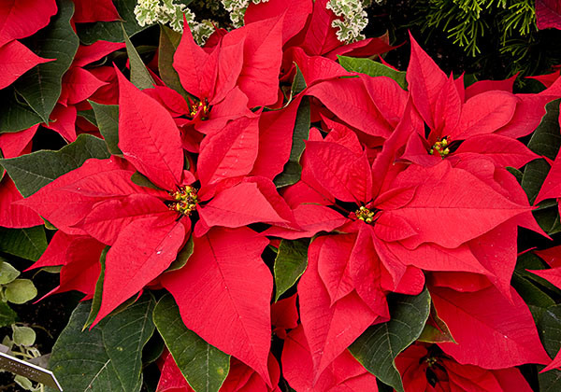

King Moravian Church
2023

King Moravian Church
228 West Dalton Road
King, NC 27021

