May 2025

KMC Notes


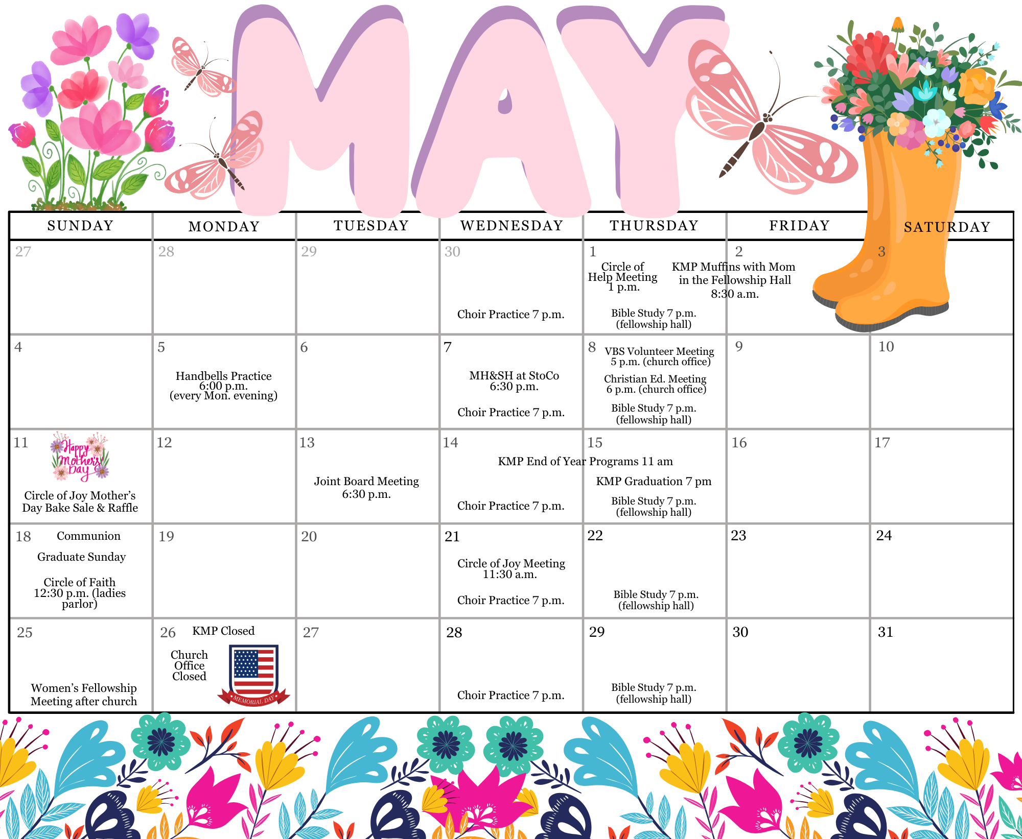

Thank You for Easter!

In the Moravian Church, we often believe that the way our particular church conducts services is the standard Moravian way. For most of us, especially if we don't change congregations, our understanding of what is considered the “Moravian way” remains largely unchanged. Ministers, however, experience a variety of "Moravian ways" as they move between churches. While there isn't a wide variance, details often differ. This becomes particularly interesting during the first Lent and Easter at a new church.
Easter of 2017 marked my first at Macedonia, and Easter of 2024 was my last there. I spent eight years acclimating to that church's particular "Moravian way." Even during COVID, when adjustments were necessary, there remained a focus on a particular approach. King has maintained its traditions similarly. You have done things the same way for some time. So, when I arrive with my own understanding and you have your established methods, it can make for a somewhat awkward first Lent and Easter season together.
I didn't know exactly what I was expecting; my main hope was simply not to make any mistakes. This past Lent and Easter season has been incredibly special to me. The church extended nothing but grace during this unique time, and I hope that, despite any awkwardness of having a new minister with a different perspective, Lent, Holy Week, and Easter were special for you as well.
To everyone who helped with our Palm Sunday and Holy Week celebrations—whether by serving as a diener, singing in the choir, managing the sound/live stream, assisting with readings, preparing the cross for the walk, or contributing to Easter Sunday by preparing the sunrise service, bringing food for breakfast, or participating in the 11 a.m. service—thank you so much. Your efforts made the season truly special.
Zach

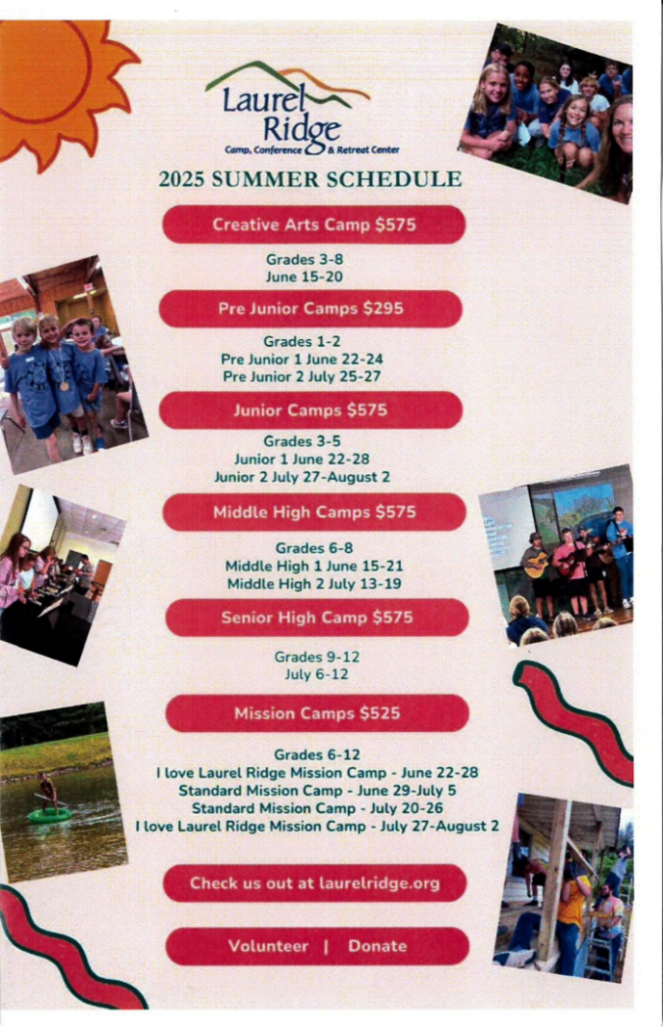

IMPORTANT CAMP SCHOLARSHIP INFORMATION
Our church provides a camp scholarship for our young people who attend church camp at Laurel Ridge. Our church will pay one-half of the camp fees for one camp for any of our members and family members who are active in our congregation. When you register, please use the code “king2025”. If there is a financial need, please let us know because there may be other funding sources for our church camps.
Financials  Offerings received through April 29: $119,282  Budget expenses through April 29: $139,877  2025 monthly contribution for shared Moravian Church Ministries: $4,956.44 per month has been paid through April. | 

May Birthdays
2 – Robert Jones  2 - Bryce Shore  4 - Jeff Burton  5 - Jennifer Shore  6 - Kim Thomas  7 - Nancy Witt  7 - Natalie Simpson  9 - Joy Jones  10 - Tim Justis  13 - Kristy McEwan  15 - Scott Cardwell  17 - Kirt Earley  18 - Logan Cline  18 - Parker Pratt  19 - Drake Flynt | 20 - Carolyn Byerly  20 - Cynthia Sevier  20 - Fran Lucas  20 - Tyler Moran  21 - C.W. Hill  21 - Charlie Sevier  22 - Rex Mathis  23 - Charles Cline  23 - Connie Hughes  24 - Isadonna Hartgrove  25 - Kyle Leonard  26 - Daphne Davis  27 - Sandy Emery  27 - Lacey Grubbs  29 - Charlie Reeves

WOMEN’S FELLOWSHIP MEETING:
The Women’s Fellowship will meet after church on May 25th at the home of Holly Mathis (2110 Jefferson Oaks Dr. Rural Hall)

CIRCLE OF JOY MEETING:
The Circle of Joy will meet on Wednesday, May 21st, at 11:30 at Susan Smith's home (1055 Voss Hill Drive, King). Please bring your own lunch. Dessert and beverages will be provided.

WELCOME TO KMC!
We welcome Stephen, Leslie, and Scarlett Peters to the King Moravian Church Family. 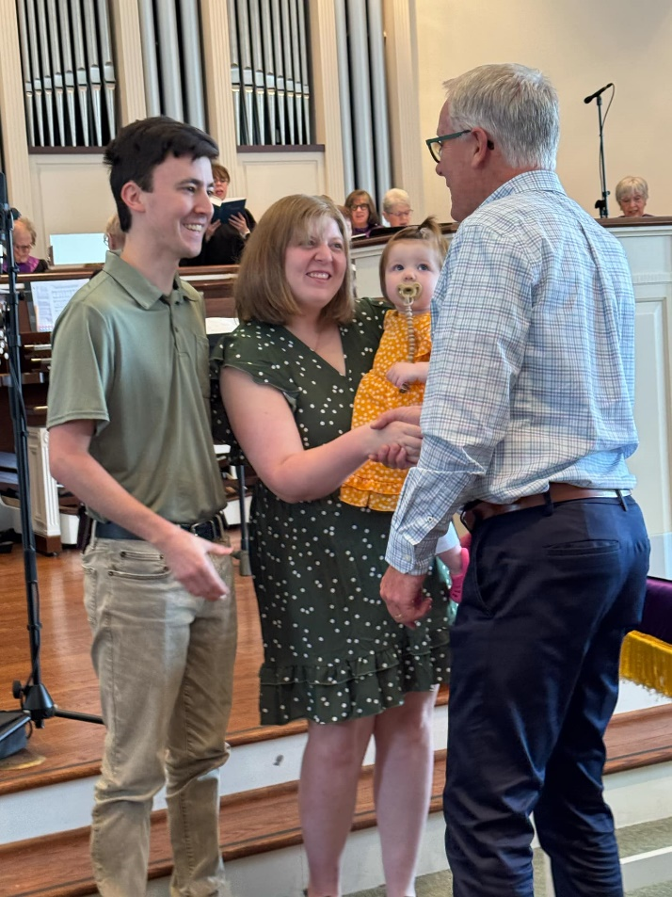

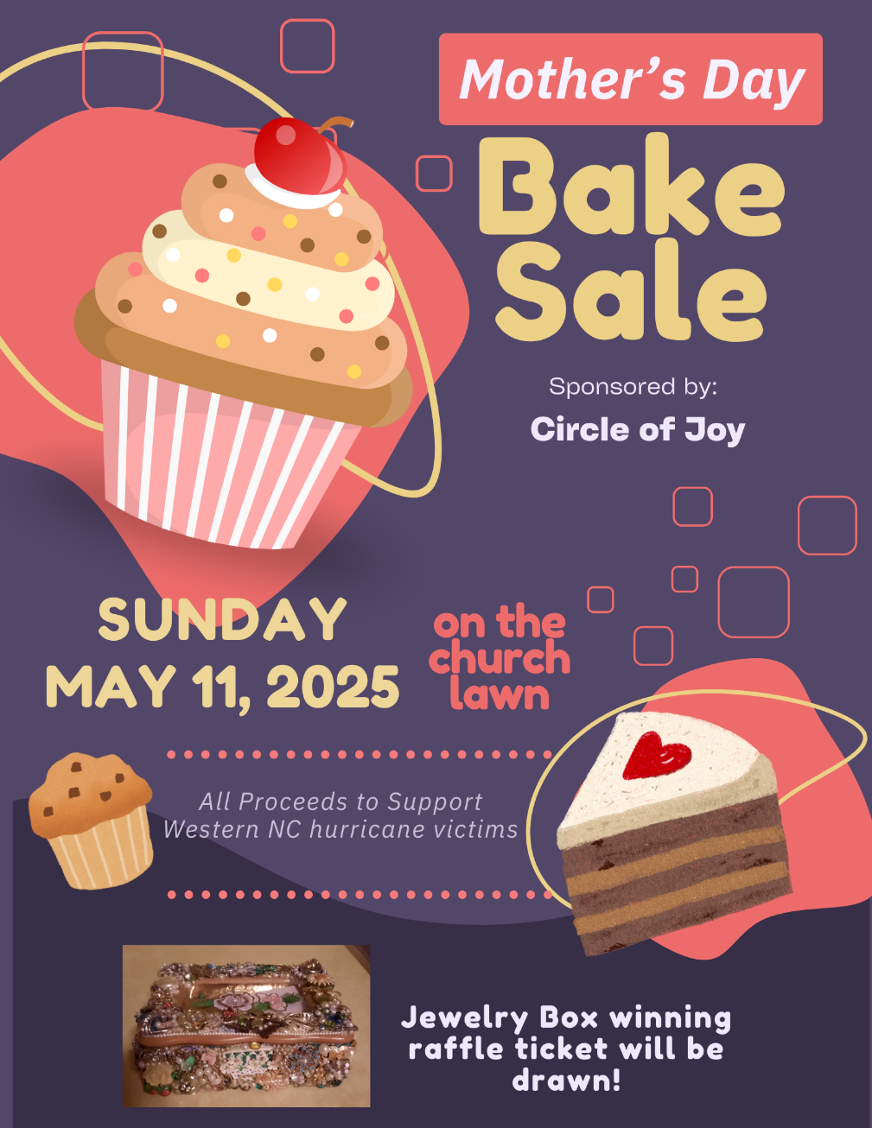

To register for Summer Fun, you can find the form on the church website or in the church narthex!

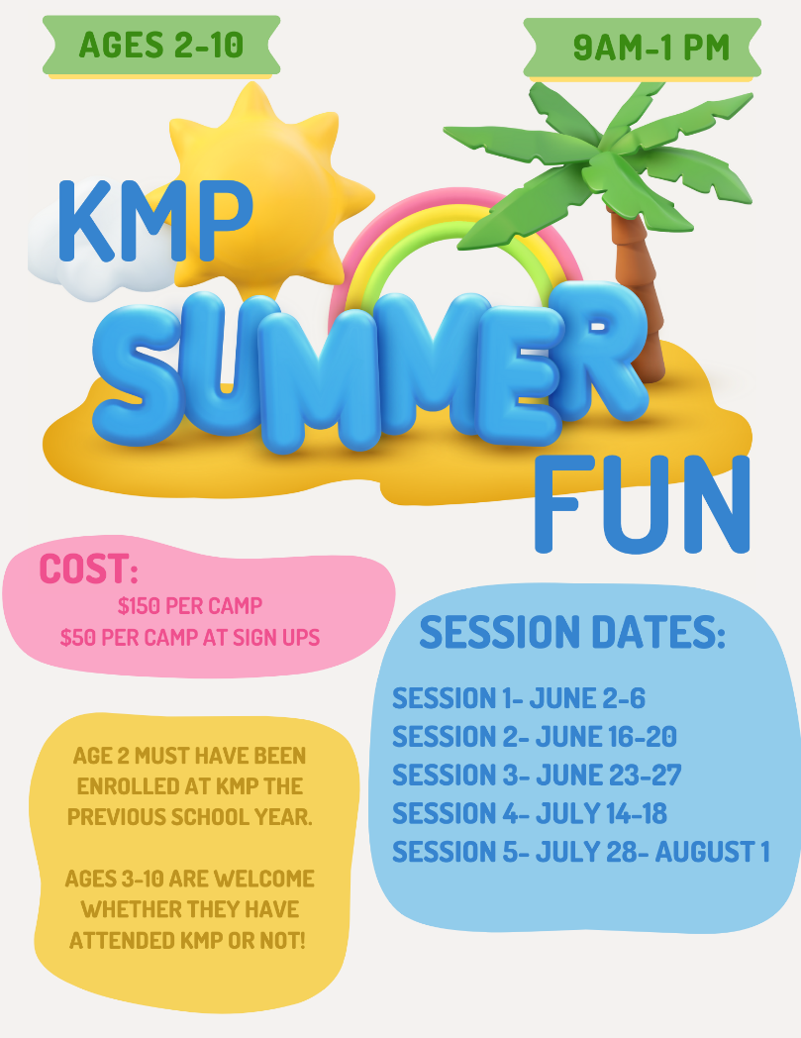

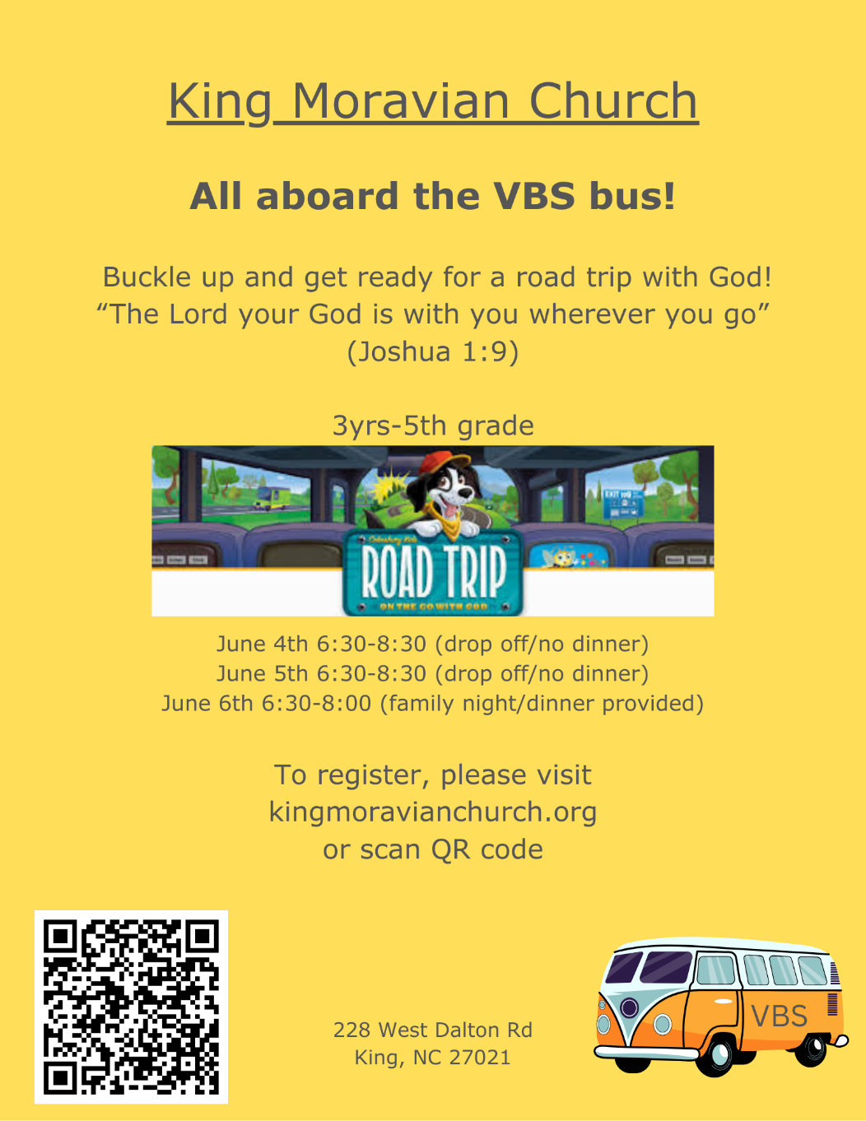

PRESCHOOL!
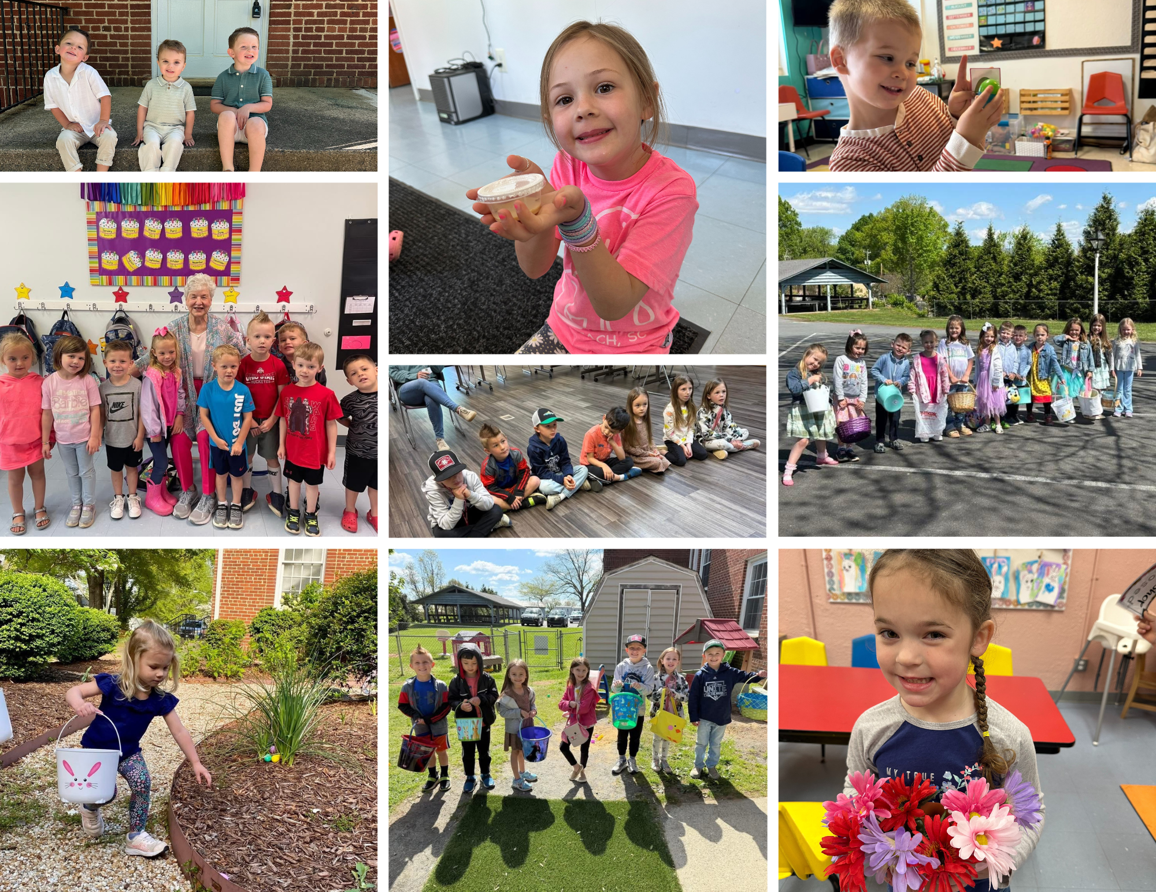

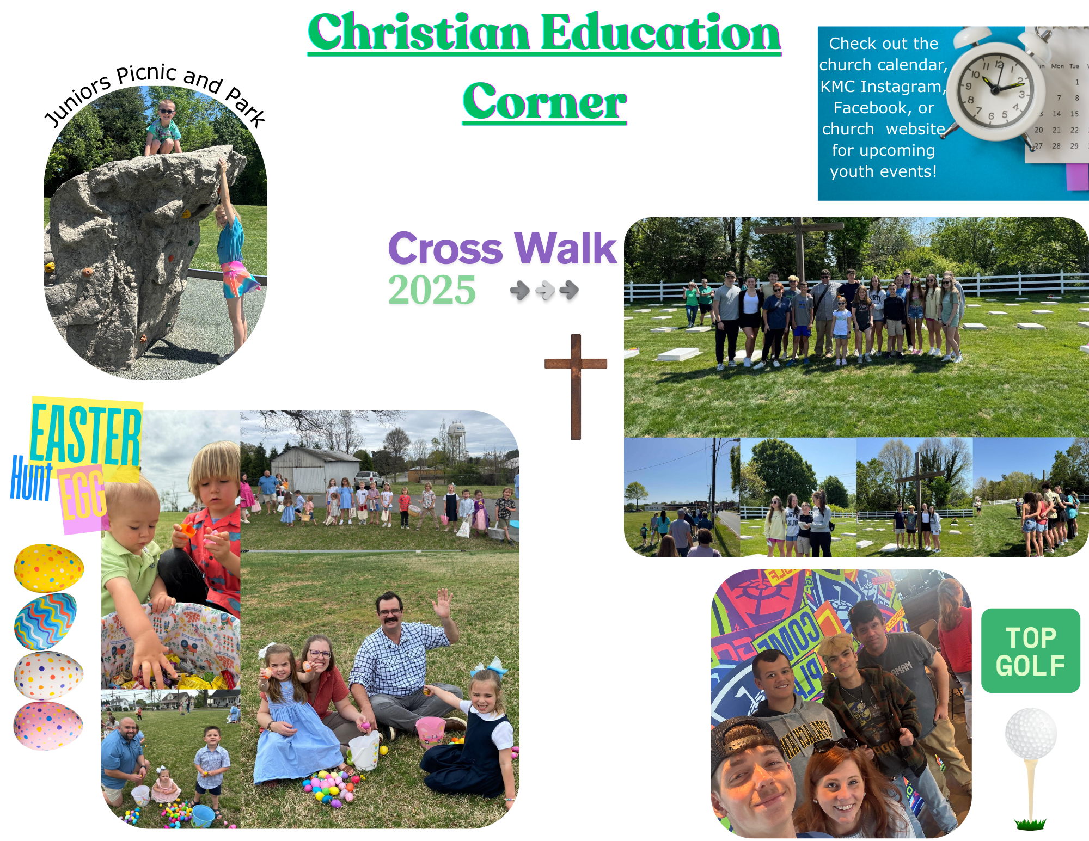

KMC Notes
May 2025
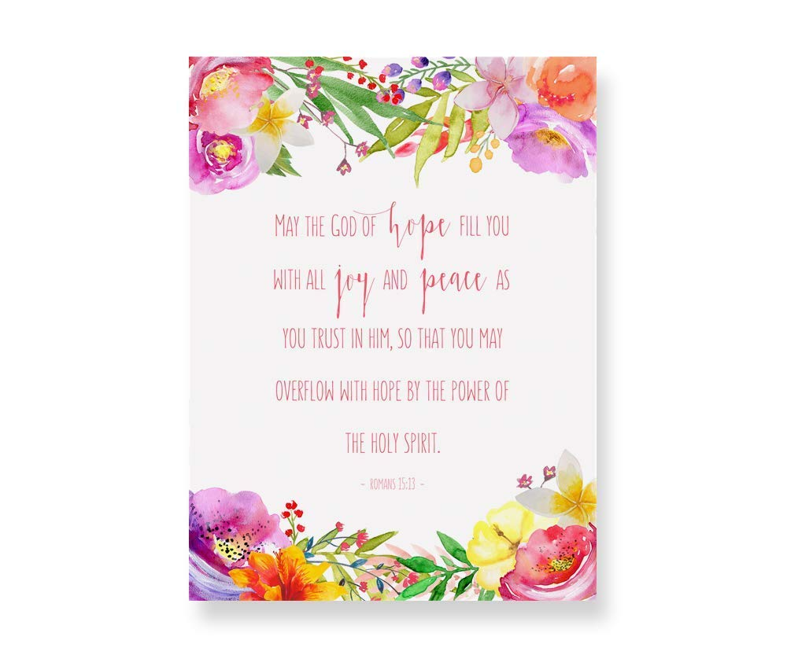

King Moravian Church
228 West Dalton Rd.
King, NC 27021

