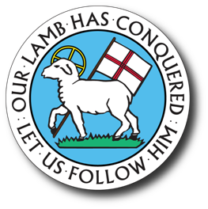
In essentials, unity; in non-essentials, liberty; and in all things, love.
King Moravian Church
228 W. Dalton Rd., King, NC 27021
Office Phone: 336-283-5322
Office Email: kingmoravianchurchoffice@gmail.com
Rev. Douglas C. Rights: pastordoug.kingmoravianchurch@gmail.com

Dear Student,

We would like you to be aware of the Isaac and Mary Ella Booe, the Braxton Brandon, Mark and Heather Johnson, and Jones Family Scholarships. These four scholarships are available to students who are members in good standing of King Moravian Church, and who have been accepted by an accredited institution for the 2024-2025 school year. These four scholarships are based on qualifications and need.

Each scholarship is a one-time annual award; the Booe scholarship is $1,000.00, the Johnson scholarship is $1,000.00, the Brandon scholarship is $500.00 and the Jones Family scholarship is $500.00. The Johnson scholarship is intended for a graduating high school senior. The Brandon scholarship is available for undergraduate students only, while the Booe and Jones scholarships may be used for undergraduate or graduate studies. The scholarships will be paid to the institution of choice, half paid in the fall semester and half paid in the spring semester.

Attached is an application to be completed and returned to the church office to be forwarded to the Scholarship Committee. All information contained therein will be regarded as confidential. Applications must be received by May 1st.

We invite you to submit an application. One application will serve for all scholarships.
In Christian Love,

King Moravian Church
Scholarship Committee

Brandon, Booe, Johnson, and Jones Family Scholarship
Application Instruction Sheet
To include:

- Information pages (application)
- A copy of your most recent transcript.
- A letter of recommendation from an academic teacher and a church member; these letters should be given to you and included in your application packet that you bring to the office.
- An essay (about 250 words) concerning your personal feelings, hopes, concerns, and ambitions.
- An essay (about 250 words) about your involvement in the life of the church and how this has impacted you.
- An essay: Why do you need this scholarship?

