June 2025

KMC Notes


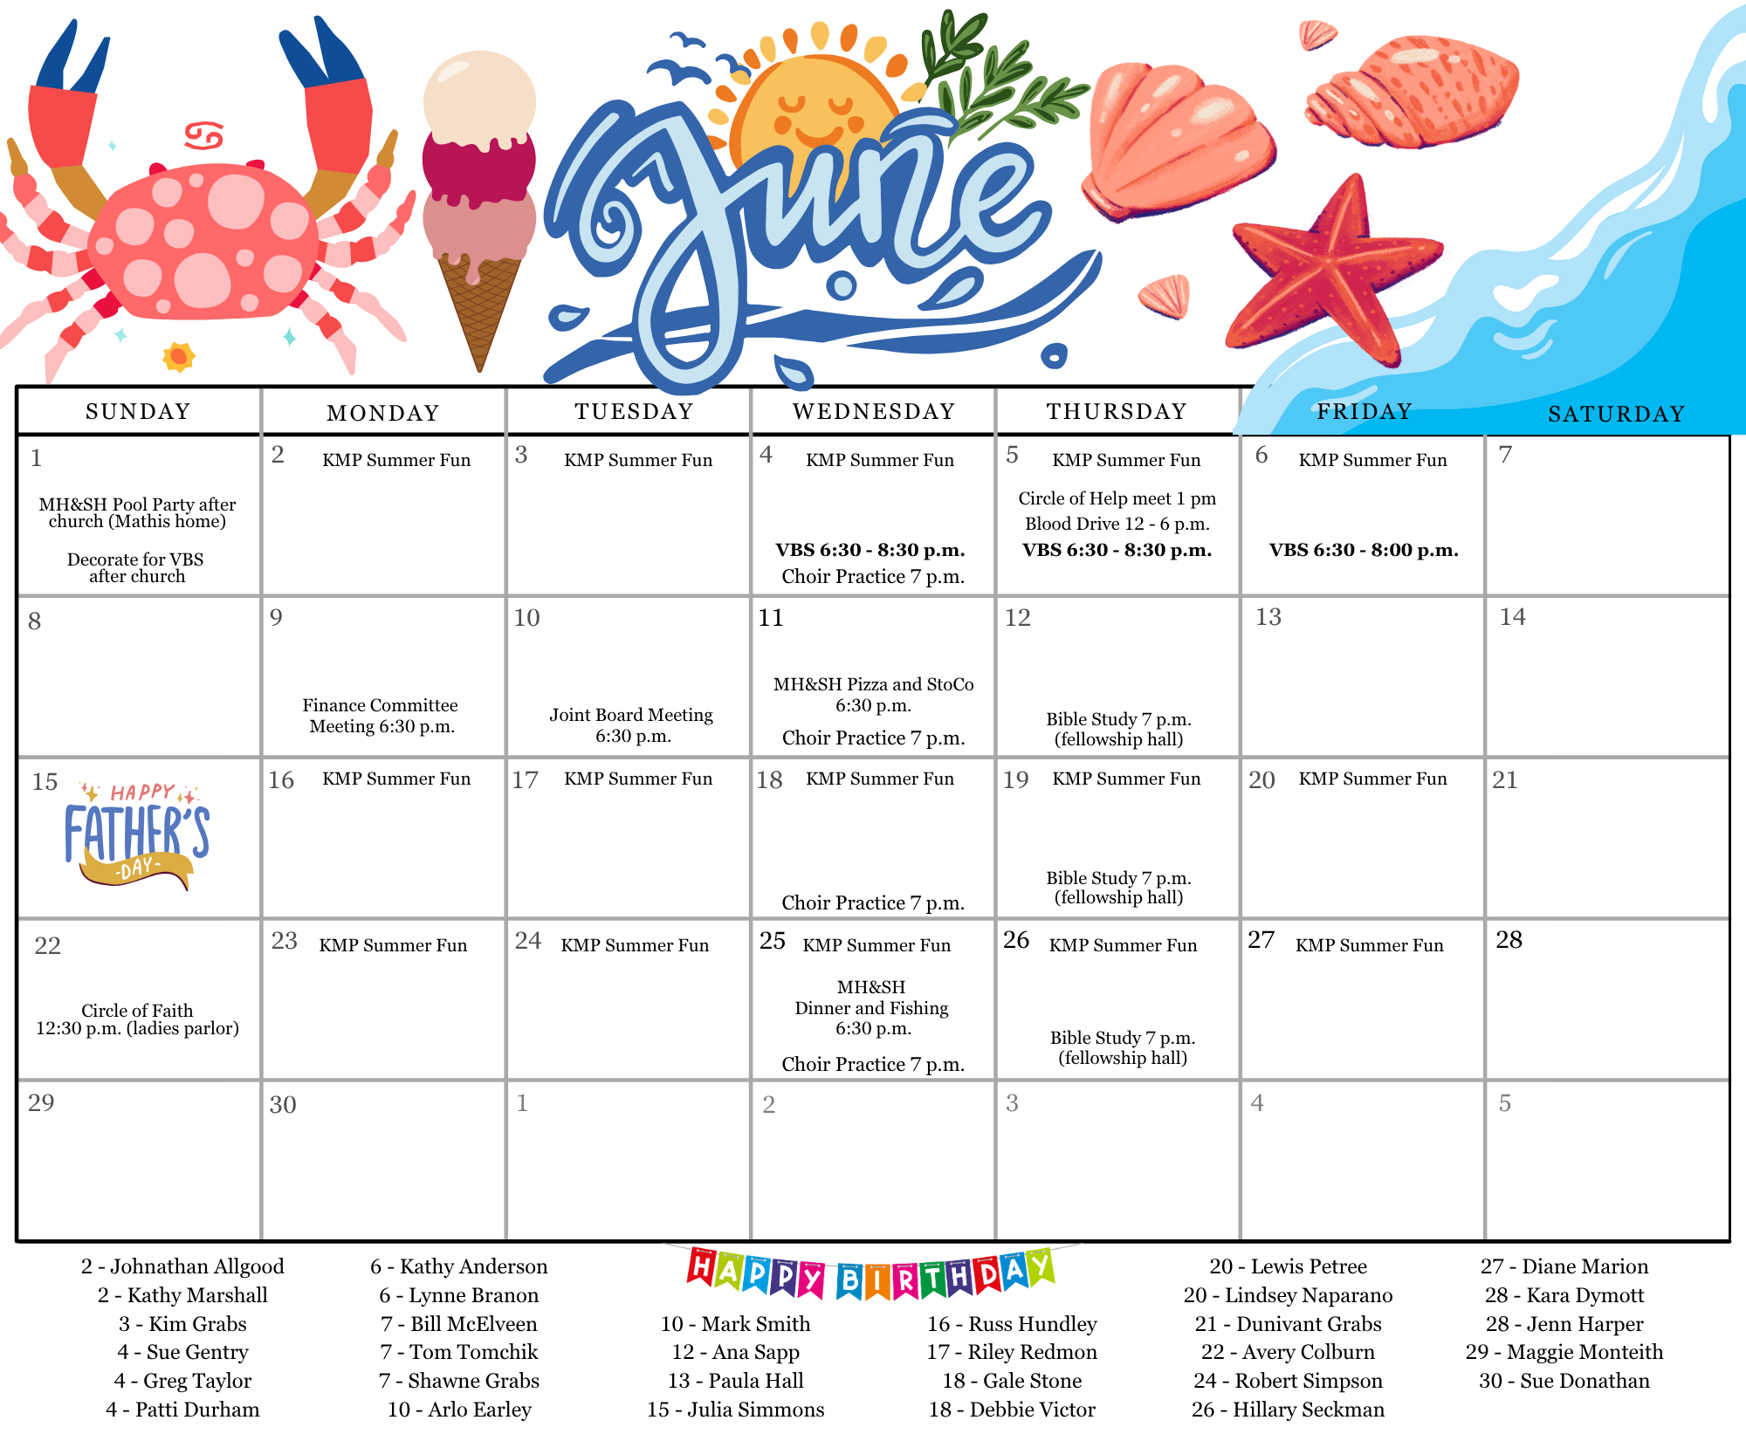

Monthly Musings
I don’t like Memorial Day. That’s not completely accurate—I should say I don’t like the time of year that Memorial Day is in. Ever since I can remember, willingly being outside during summer is not something I enjoy. I’m highly allergic to just about any plant that grows, and I have wicked bad asthma. So, needless to say, summertime and outdoor activities aren’t my jam.
In Charles Dickens’ A Christmas Carol, Ebenezer Scrooge laments how people think he should be happy during Christmas, and he says, “You keep Christmas in your way and let me keep it in mine.” When it’s a bright, sunny, warm summer day, just perfect for a cookout, I truly understand Scrooge’s sentiment. When people insist that a beautiful summer day is just ripe for going outside, I feel like a Scrooge. Memorial Day is the start of a bunch of summer holidays, most of which folks celebrate outdoors in the heat.
This past Memorial Day was a joy! It didn’t get above 60 degrees, and it was cold and grey—my kind of day! The day made me think of a recent trip to Ireland, where it was cold and grey, and I was happy wrapped up in flannel shirts and wool sweaters. But I know for a lot of people, this past Memorial Day was not what they hoped for because of the weather. That little weather anomaly really fascinates me, because it’s a reminder of what the book of Ecclesiastes says—that seasons come and go, often unpredictably. Life’s kind of like that too.
Thinking about that unexpected coolness and gloom, I started to wonder: how often do we get caught up wishing for a different season? More sunshine, less struggle, something easier? Maybe it’s worth asking ourselves—are we trying to rush through where we are, or are we trying to figure out how to live well in this season? It’s natural to want things to be different, but maybe real growth happens when we learn to live well in the moment we’re in. Just as the weather can surprise us, life throws us curveballs we don’t expect.
Maybe it’s less about trying to change the season, or understanding why the seasons shift, and instead learning how to live in the season we are in. Ecclesiastes 3 points out that understanding the seasons, why they change when they do, is something that is reserved for God, not us. But God doesn’t leave us alone in the crazy, unexpected season shifts. God gives us all the ability to figure out how to live in the seasons, so long as we don’t get preoccupied with the why.
What season of life are you in right now? Was it expected or unexpected? Where are your thoughts right now? Are they in trying to figure out how to live during this time, or is your brain whirling around simply trying to figure out why?
Contemplating why God is causing a season—especially in times of trial—most likely will lead you to things that are not true. Why is this season happening? Well, maybe it’s because God doesn’t love me, or this is some sort of divine judgment on my character. Maybe I am paying for something my family has done. Why are things going well? Because I’m the best. But trying to figure out the “why” will most likely lead you astray. How do I make it through right now? Ask others who have been through this how they did it. How do I deal with this pain right now? Surround myself with people who care for me. What do I do with the abundance I have? Figure out how to share it in a meaningful way.

What Season are you in?
Zach

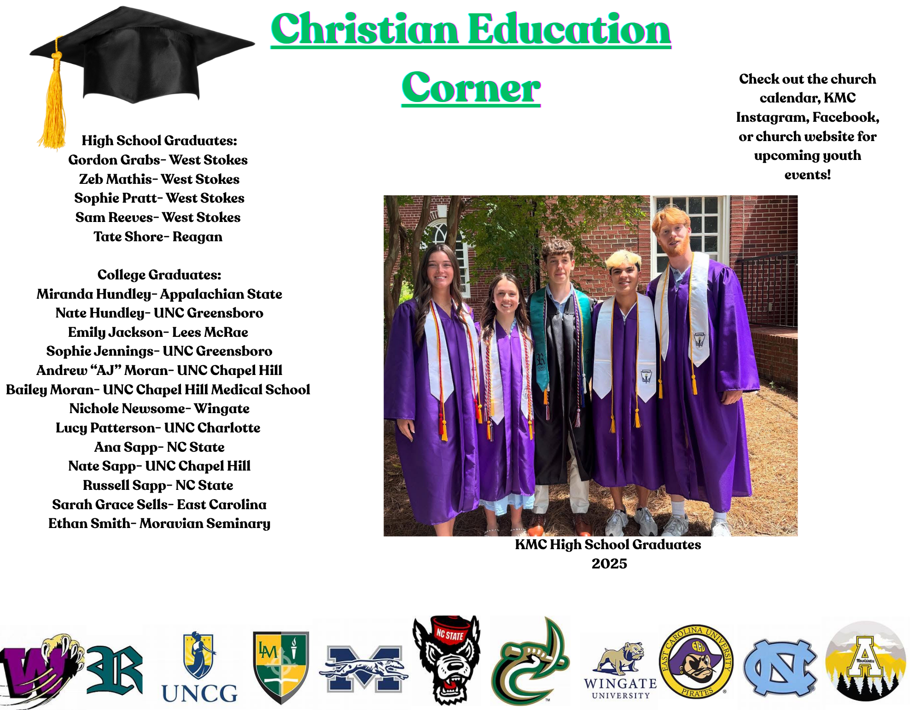

HANDBELLS REHEARSALS:
Handbells will pause rehearsals during the summer months.

CIRCLE OF HELP MEETING:
The Circle of Help will meet on Thursday, June 5th, at 1:00 p.m. at the home of Linda Wilson. Bring your lunch. Desserts and beverages will be provided. (Carpool from the church at 12:45 p.m.)

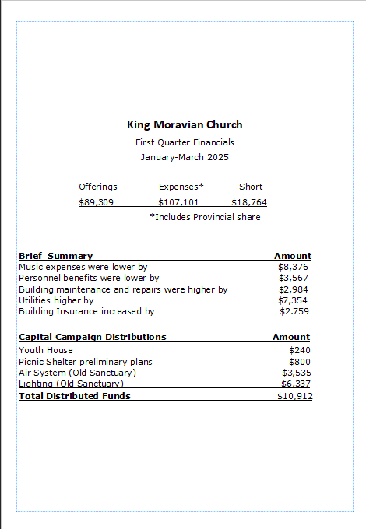

Connect with us!

@kingmoravianchurch


@kingmoravianchurch1924

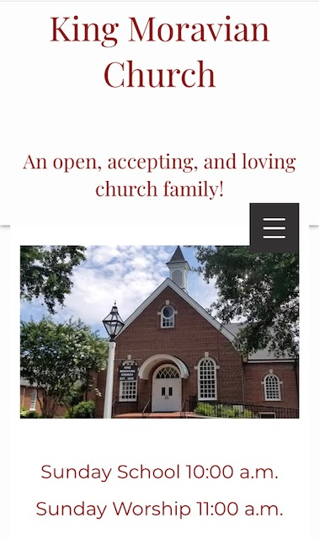
kingmoravianchurch.org


IMPORTANT CAMP SCHOLARSHIP INFORMATION
Our church provides a camp scholarship for our young people who attend church camp at Laurel Ridge. Our church will pay one-half of the camp fees for one camp for any of our members and family members who are active in our congregation. When you register, please use the code “king2025”.

If there is a financial need, please let us know because there may be other funding source for our church camps.

