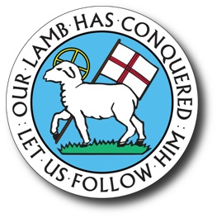

Application for Brandon and Booe Scholarships of King Moravian Church

King Moravian Church
228 W. Dalton Rd. King, NC 27021
Office Phone: 336-283-5322
Office Email: office@kingmoravianchurch.org
Rev. Douglas C. Rights; doug@kingmoravianchurch.org

Applicant Information
Full Name:
 | Last |  | First | M.I.
 |  | Date of birth: Age: Grade:
Address:
 |  | Street Address |  |  | Apartment/Unit #

 | City | State | ZIP Code

Phone: |  | Email | :

Name of Father: |  | Occupation:
Name of Mother: |  | Occupation:

Do you have brothers/sisters in college?: |  | If so, where?:

Your proposed career plans:

Honors, special achievements, clubs, offices held:

_______________________________________________________________________________________________

List activities in school, community, and church which have been meaningful to you:

_______________________________________________________________________________________________
_______________________________________________________________________________________________
Overall academic average: ___________ Class Rank: ___________ SAT or ACT Scores: ____________________
Have you been accepted to a college?: _______ Where?: _______________________________________________

What scholarships have you received?: ______________________________________________________________

______________________________________________________________________________________________

Name other scholarships to which you have applied: ____________________________________________________
_______________________________________________________________________________________________

Disclaimer and Signature

I, _______________________________hereby declare that, to the best of my knowledge, the foregoing statements are correct.
Signature of Student: |  | Date:

Signature of Parent: |  | Date:

