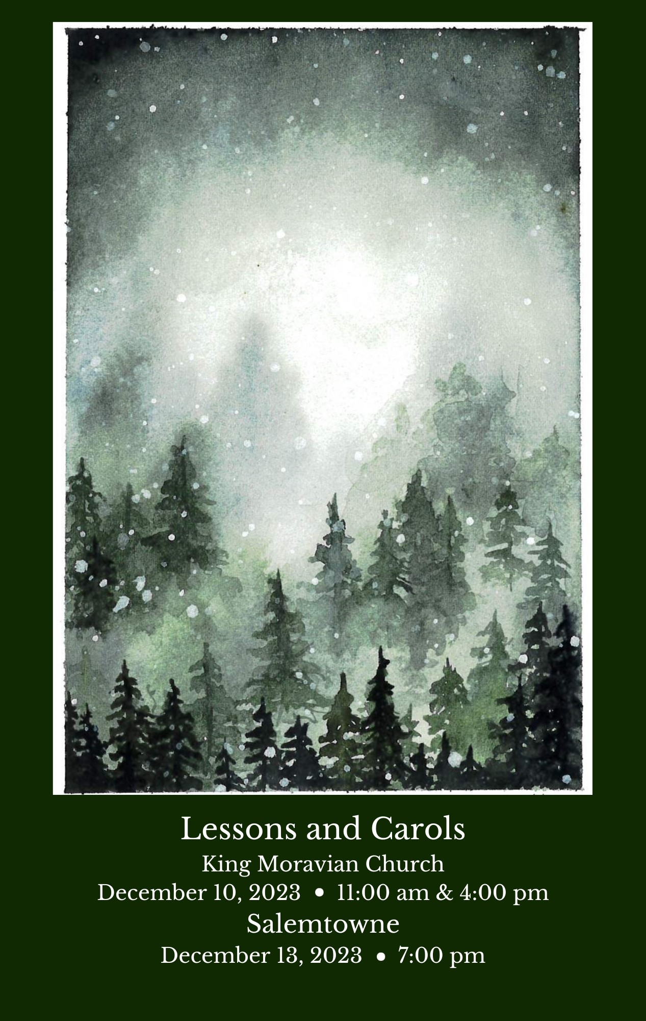
This service is a gift of music given to the community by King Moravian Church. May this be an opportunity for inspiration, reflection, and connection to the majesty of sacred music. We welcome all children to hear and experience this music and message. Welcome! We are grateful for your presence. Please silence all electronic devices.
Welcome

Reading I: Genesis 1:1-5

Orchestra – Adagio, IX Nimrod from Enigma Variations Edward Elgar
(1857-1931)

Hymn – O Come, O Come, Emmanuel 15th Century French
arr. John Rutter
All – O come, O come, Emmanuel, and ransom captive Israel
That mourns in lonely exile here, until the son of God appear.
Rejoice! rejoice! Emmanuel. Shall come to thee, O Israel.

All – O come thou Rod of Jesse, free Thine own from Satan’s tyranny,
From depths of hell thy people save, And give them vict’ry o’er the
grave. Rejoice! rejoice! Emmanuel. Shall come to thee, O Israel.

Choir – O come, thou Dayspring, come and cheer. Our spirits by thine
advent here. Disperse the gloomy clouds of night,
and death’s dark shadow put to flight. Rejoice! rejoice!
Emmanuel. Shall come to thee, O Israel.

All – O come, O come. thou Lord of might, who to thy tribes on Sinai’s
height, In ancient times didst give the law. In cloud and majesty,
and awe. Rejoice! rejoice! Emmanuel. Shall come to thee, O Israel.

All – O come, thou Key of David, come, And open wide our heav’nly
home. Make safe the way that leads on high, and close the path to
misery. Rejoice! rejoice! Emmanuel. Shall come to thee, O Israel.

Reading II: Matthew 2:1-11
Lost In the Night Kyle Haugen (b. 1973)
Lost in the night do the people yet languish, longing for morning the darkness to vanquish, plaintively sighing with hearts full of anguish. Will not day come soon? Will not day come soon?

Must we be vainly awaiting the morrow? Shall those who have light no light let us borrow, giving no heed to our burden of sorrow? Will you help us soon? Will you help us soon?

Sorrowing wanderers, in darkness yet dwelling, dawned has the day of a radiance excelling, death's deepest shadows forever dispelling. Christ is coming soon! Christ is coming soon!

Light o'er the land of the needy is beaming; rivers of life through its deserts are streaming, bringing all peoples a Savior redeeming. Come and save us soon! Come and save us soon!

Three Excerpts from Christus Felix Mendelssohn (1809-1847)
I. When Jesus, our Lord, was born in Bethlehem, in the land of Judea;
behold, from the east to the city of Jerusalem there came the wise
men and said:
II. Say, where is He born, the King of Judea? For we have seen his star,
and are come to adore him.

III. There shall a star from Jacob come forth, and a scepter from Israel
rise up to dash in pieces princes and nations. How brightly beams
the morning star! With sudden radiance from a far – with light and
comfort glowing. Thy Word, Jesus, inly feeds us, rightly leads us, life
bestowing. Praise, oh praise such love o’er flowing!

Reading III: Luke 2:8-14

Hymn – All Silent Was the Night Theodor Liley Clemens, Moravian (1858-1933)

All All silent was the night, and peaceful Bethehem’s hill,
when God’s own herald took his flight to tell of God’s good will.

Refrain: Joy! Joy! Joy! Joy! Joy the angel sang; the hosts above
took up the strain, and heav’n with praises rang.

All Beneath a lowly shed, with oxen in the stall,
the straw and manger for his bed slept the great Lord of all. (Refrain)

Choir Messiah promised he; likeness of man to wear,
ransom and substitute to be, and all their woes to bear. (Refrain)

All Then raise we now our song, for us this Savior came, his praises
sound both loud and long, and magnify his name. (Refrain)
Angels We Have Heard On High A French Carol
Arr. by John Rutter (b. 1945)

Angels we have heard on high, sweetly singing o’er the plains,
And the mountains in reply, echoing their joyous strains.
(Refrain) Gloria in excelsis Deo. Gloria in excelsis Deo.

Shepherds, why this jubilee? Why your joyous strains prolong?
What the gladsome tidings be, which inspire your heav’nly song? (Refrain)

Come to Bethlehem and see, Him whose birth the angels sing;
Come, adore on bended knee, Christ the Lord, the newborn King. (Refrain)

Three Kings of Orient J. H. Hopkins, Arr. by John Rutter (b. 1945)

We three kings of Orient are, bearing gifts we traverse afar.
Field and fountain, moor and mountain, following yonder star.
(Refrain) O star of wonder, star of night, star with royal beauty bright,
Westward leading, still proceeding, guide us to thy perfect Light.
Born a king on Bethlehem's plain, gold I bring to crown Him again,
King forever, ceasing never, over us all to reign. (Refrain)
Frankincense to offer have I. Incense owns a Deity nigh.
Prayer and praising all men raising, worship Him, God on high. (Refrain)
Myrrh is mine: Its bitter perfume. Breaths a life of gathering gloom.
Sorrowing, sighing, bleeding dying, sealed in the stone-cold tomb. (Refrain)
Glorious now behold Him arise, King and God and Sacrifice.
Alleluia, alleluia! Sounds through the earth and skies. (Refrain)

Reading IV: Luke 2:15-19

Hymn – Once in Royal David’s City H. J. Gauntlet (1805-1876)

Solo Once in royal David's city, stood a lowly cattle shed,
Where a mother laid her baby, in a manger for his bed:
Mary was that Mother mild, Jesus Christ her little Child.

Choir He came down to earth from heaven, who is God and Lord of all,
And his shelter was a stable, and his cradle was a stall:
With the poor and mean and lowly, lived on earth our Saviour holy.

All And through all His wondrous childhood, he would honor and obey,
Love and watch the lowly maiden, in whose gentle arms He lay:
Christian children all must be, mild, obedient, good as He.

All And our eyes at last shall see him, through his own redeeming love,
For that Child so dear and gentle, is our Lord in heaven above:
And he leads his children on, to the place where he is gone.

All Not in that poor lowly stable, with the oxen standing by,
We shall see him: but in heaven, set at God's right hand on high,
Where like stars his children crowned, all in white shall wait around.

We Bring our Tithes and Offerings

O Little Town of Bethlehem St. Louis (Redner) alt.
arr. Dan Forest (b.1978)

O little town of Bethlehem, how still we see thee lie;
Above thy deep and dreamless sleep the silent stars go by.
Yet in thy dark streets shineth the everlasting light;
The hopes and fears of all the years are met in thee tonight.

For Christ is born of Mary, and gathered all above,
While mortals sleep, the angels keep their watch of wond'ring love.
O morning stars, together proclaim the holy birth;
And praises sing to God the King, and peace to men on earth.

How silently, how silently the wondrous gift is giv'n!
So God imparts to human hearts the blessings of his heav'n.
No ear may hear his coming, but in this world of sin,
Where meek souls will receive him still, the dear Christ enters in.

O holy Child of Bethlehem, descend to us, we pray;
Cast out our sin and enter in, be born in us today.
We hear the Christmas angels the great glad tidings tell;
O come to us, abide with us, our Lord Emmanuel.

Prayer for Love and Light

Silent Prayer

Love’s Pure Light Elaine Hagenberg (b. 1979)
Silent night, holy night, all is calm, all is bright;
Round yon virgin mother and child. Holy infant so tender and mild.
Sleep in heavenly peace, sleep in heavenly peace.
Cum Sancto Spiritu Antonio Vivaldi (1669-1741)
And with the Holy Ghost, and glory of God the Father. Amen.

Congregational Response: (please stand if you are able)
Leader: The Word came and dwelt among us, and that Word was the Light of all creation.

People: FOR UNTO US A CHILD IS BORN, UNTO US A SON IS GIVEN; AND THAT CHILD, JESUS CHRIST, IS TRUTH AND LIGHT. THIS LIGHT SHONE IN THE DARKNESS OF THE ANCIENT WORLD, AND SHINES IN THIS WORLD OF OURS TODAY.

Leader: So may we depart in Peace, in Love, in Joy, and in Hope; for we have seen His glory.

People: WE HAVE HEARD THE MESSAGE OF THE MUSIC; WE HAVE HEARD THE MUSIC OF THE MESSAGE. WE HAVE LISTENED WITH OUR HEARTS. WE WILL SHOW THIS MESSAGE IN OUR LIVES. PRAISE AND GLORY BE TO GOD. HALLELUJAH! HALLELUJAH!

Hallelujah, from The Messiah George Fredric Handel (1685 - 1759)

Hymn – Hark the Herald Angels Sing Felix Mendelssohn
vs 3 arranged by John Rutter (1945)

All Hark! the Herald angels sing, glory to the newborn king;
Peace on earth and mercy mild, God and sinners reconciled;
Joyful all ye nations rise, join the triumph of the skies,
With the angelic host proclaim, Christ is born in Bethlehem. (Refrain)

Refrain: Hark! The herald angels sing, glory to the newborn king.
All Christ, the highest heaven adored, Christ, the everlasting Lord;
Late in time behold him come, offspring of a virgin’s womb;
Veiled in flesh the Godhead see, hail the incarnate deity,
Pleased as man with men to dwell Jesus, our Emmanuel. (Refrain)

All Hail the heaven born Prince of Peace! Hail the Sun of Righteousness!
Light and life to all he brings, risen with healing in his wings;
Mild he lays his glory by, born than man no more may die,
Born to raise the sons of earth, born to give them second birth.
(Refrain)

Cover image by Kate Helke.
Readers: (11:00 a.m.) Zeb Mathis, Lynne Doby Rex Mathis, Homer Dearmin
(4:00 p.m.) Cynthia Sevier, Chris Bullin, Leah Simpson, Ken Lyda

Advent Candle Lighters: (11:00 a.m.) Zollie and Renee Smith with their granddaughters,
Mary and Frances
(4:00 p.m.) The Heath Family

Orchestra

Violin John Pruett Flute Peter Shanahan
Annette Covington

Viola Jessica Ronnevik Oboe Ashley Barrett
Annie Jeng (11:00) Matthew Covington

Cello Laura Shirley (11:00) Clarinet David Allen
Meaghan Skogen (4:00)
Emily Grissing (Salemtowne)

Bass Stacy Alexis Ellerbe Smith Bassoon Cory Jones

Harp Helen Rifas French Horn Joe Mount
Tim Papenbrock (11:00)
Ben Weber (4:00)

Timpani Erik Schmidt Trumpet Russell Smith

All music and lyrics in this bulletin are printed by permission through Christian Copyright License International (CCLI) #110-92673. Distribution of or sharing this information without permission is a violation of copyright regulations.

For this service of Lessons and Carols we invited singers and friends from our larger community to participate with the KMC Choir. If you are interested in being part of services like these, please submit your contact information to Drake Flynt (dflyntjr@gmail.com/ 336-403-8361).
Soprano
Ann Deal
Kim Grabs
Paula Jennings
Ann Lawrence
Fran Lucas
Desty McEwan
*Katie Muhlenkamp
Deborah G. Pyatt
Virginia Southern
Debbie Victor

*Soloist
Tenor
William Barham
Jennifer Burge-Carter
Andy Cromer
David Durham
Budge Gage
Don George
Freddie Johnson
Mark Johnson
Adam Plant
Alto
April S. Bullin
Margie Hall
Olivia Harper
Sally Hartgrove
Dottie Jones
Jennifer Lawrence
Emma Marsh
Ann Davis-Rowe
Sally Sipes
Bass
Bill Hall
Don Jennings
Trevor Ketterling
John New
Thao Nguyen
Kevin Sudol
Jackson Wood
King Moravian Church Choir and Staff 2023
Drake Flynt, Director of Music
Jennifer Dunn, Organist

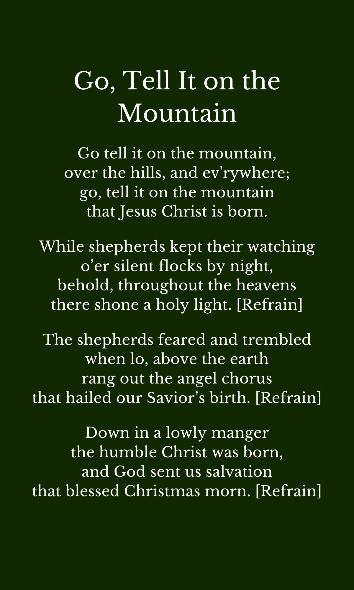
Lessons and Carols
King Moravian Church
December 16, 2018
11 AM & 4 PM

Salemtowne
December 19, 2018
7 PM

